Guide to Ordering Prints

Step one:
Open your browser to the link provided to you for your pictures for ordering.
example: http://joshberens.wixsite.com/hadley
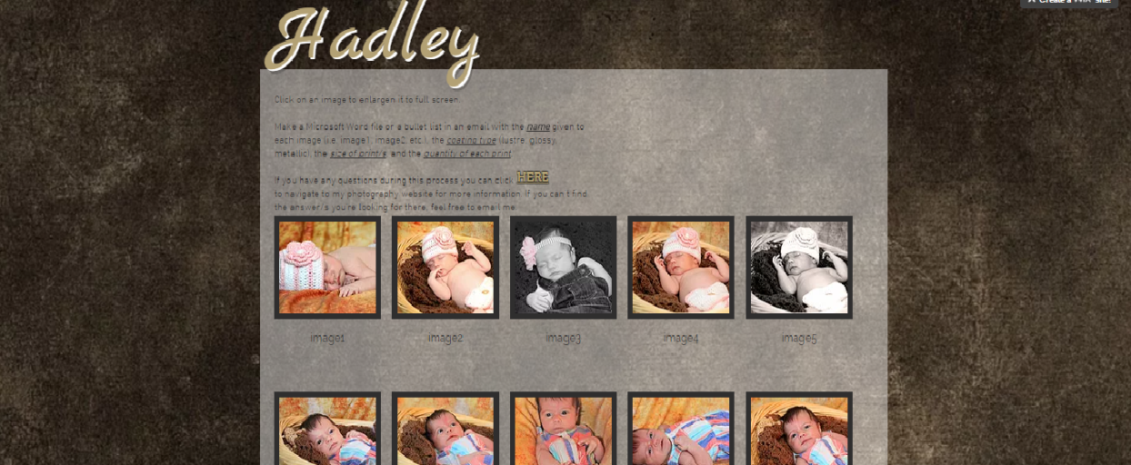

Step two:
Open another window in your browser to my website’s Pricing/Info page. (http://joshberens.wixsite.com/photography/pricing)
Click and download a PDF of the print prices as well as a spreadsheet outline to make your ordering easier.
example:
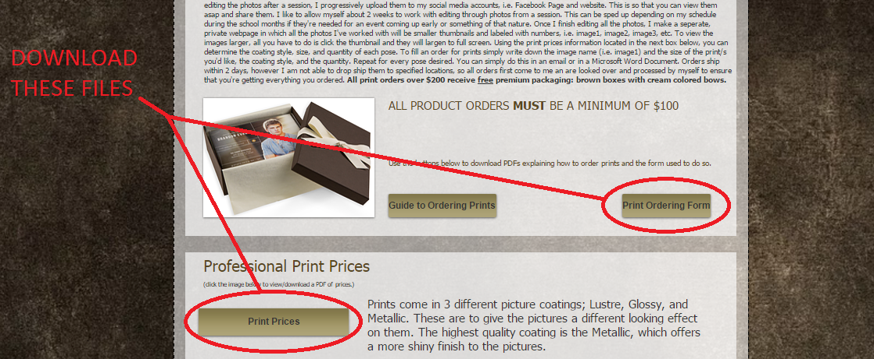
Step three:
Going back to the link given to you for ordering photos—you will notice that every image is labeled with a number (i.e. image1, image2, image3, etc.)
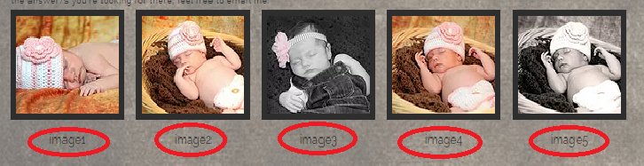
These are the numbers that you will use in correlation with the Photo # section of the Print Ordering Form.
example:
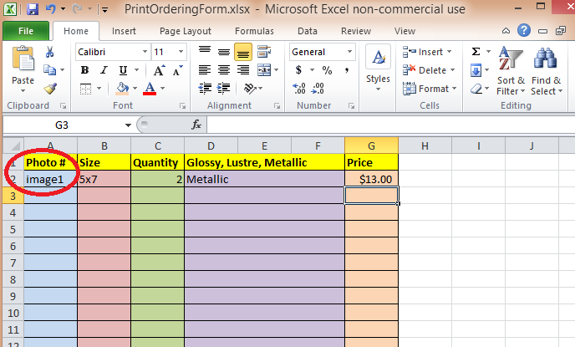

Step four:
Though most of this information is fairly straight forward, it’s important to be tedious while filling out the Print Ordering Form. You will need to fill out all other fields in the spreadsheet for every different size for every photo.
example: If I were to want (2) 5x7s of image1 and (3) 4x6s of image1 my spreadsheet would look something like this:
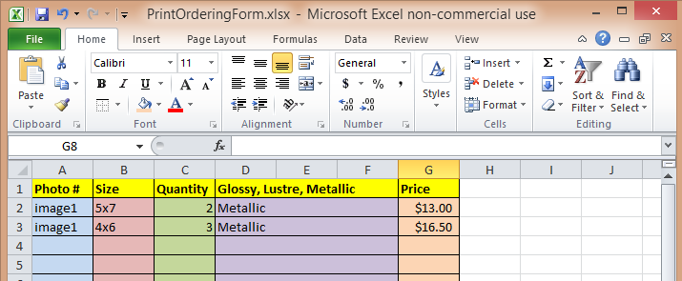
THE SAME GOES FOR IMAGE COATING.
If I wanted (2) 5x7s of image1 in Lustre as well as the ones in Metallic that I already have marked down, my spreadsheet would look something like this:
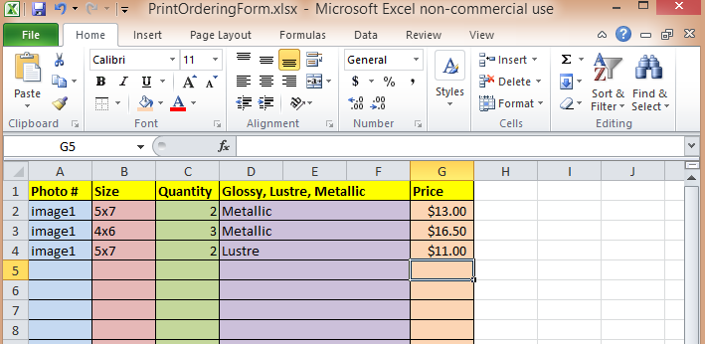
ALSO NOTE THAT YOU SHOULD BE FIGURING THE TOTAL FOR THE QUANTITY AND SIZE OF EVERY IMAGE FOR EVERY DIFFERENT COATING.
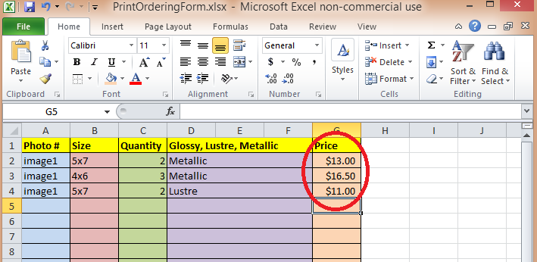
A 5x7 in Metallic coating costs $6.50. Therefore the price of two is $13.00.
A 4x6 in Metallic coating costs $5.50. Therefore the price of three is $16.50.
And so on and so forth..
PLEASE ALSO TOTAL THE PRICE OF EVERYTHING AT THE BOTTOM.
This is to make it easier for myself and to check that we’ve both gotten the total for your order.
ONCE THE FORM IS COMPLETELY FILLED OUT, PLEASE EMAIL IT TO ME ASAP:
joshberensphotography@gmail.com
PLEASE TAKE NO LONGER THAN A MONTH TO COMPLETE AND SEND ME THIS FORM FROM THE DAY I HAVE GIVEN YOU YOUR LINK TO MAKE AN ORDER.
THOSE WHO DO NOT FOLLOW THIS ARE SUBJECT TO NOT BEING ABLE TO PLACE AN ORDER AND FORFEIT ALL POSSIBILITY OF BEING A CLIENT.

